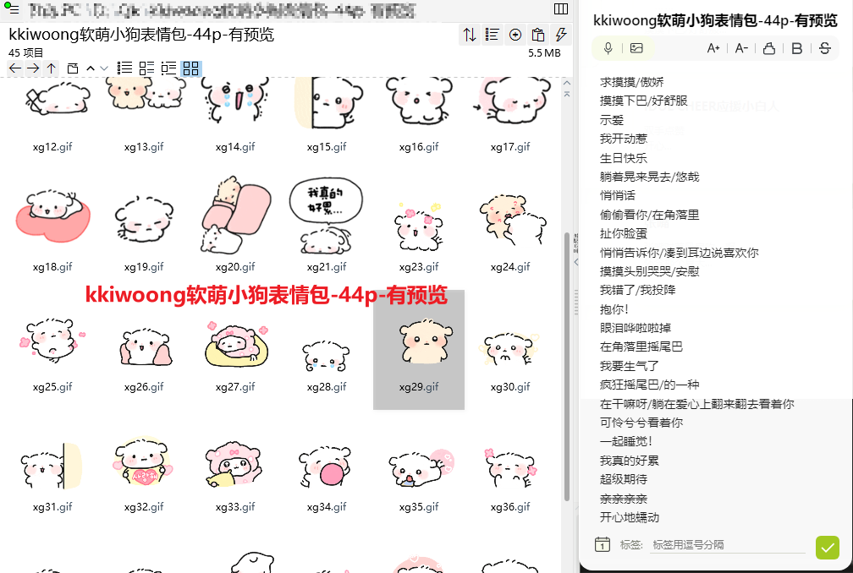
求摸摸/傲娇:https://imgbed.heliar.top/i/E9D7j-tQR4JNWfc5_xg1.gif
摸摸下巴/好舒服:https://imgbed.heliar.top/i/0PuNEqTF5J2i7a-5_xg2.gif
示爱:https://imgbed.heliar.top/i/0pK1iEVeuDaLuarq_xg3.gif
我开动惹:https://imgbed.heliar.top/i/T8WBezpcblv74G6C_xg4.gif
生日快乐:https://imgbed.heliar.top/i/ETvn7uFa7gibqhrw_xg5.gif
躺着晃来晃去/悠哉:https://imgbed.heliar.top/i/UUcfhf-c8qLmlwBr_xg6.gif
悄悄话:https://imgbed.heliar.top/i/S9raiWGr7KIZkU4f_xg7.gif
偷偷看你/在角落里:https://imgbed.heliar.top/i/60tEz3XyEZDg4VoY_xg8.gif
扯你脸蛋:https://imgbed.heliar.top/i/UeDLz1VLwyenaMdR_xg9.gif
悄悄告诉你/凑到耳边说喜欢你:https://imgbed.heliar.top/i/jYgW3D5lM6vOOXrT_xg10.gif
摸摸头别哭哭/安慰:https://imgbed.heliar.top/i/ubq6lce-K6U9U_1A_xg11.gif
我错了/我投降:https://imgbed.heliar.top/i/ywfHws7_Wrw6a8zE_xg12.gif
抱你！:https://imgbed.heliar.top/i/Ihr8NCTNyxsjCIRv_xg13.gif
眼泪哗啦啦掉:https://imgbed.heliar.top/i/3llOfnHgdYG0APlX_xg14.gif
在角落里摇尾巴:https://imgbed.heliar.top/i/rBg5fYPtH9ACibUd_xg15.gif
我要生气了:https://imgbed.heliar.top/i/nheJABTIfSOIfNMY_xg16.gif
疯狂摇尾巴/的一种:https://imgbed.heliar.top/i/gsg-f-cNPdcrZL6T_xg17.gif
在干嘛呀/躺在爱心上翻来翻去看着你:https://imgbed.heliar.top/i/e1HrixJXFa52C_Fl_xg18.gif
可怜兮兮看着你:https://imgbed.heliar.top/i/mOVz7J9qakkOArdH_xg19.gif
一起睡觉！:https://imgbed.heliar.top/i/8jgAfiI2FCVQ5Lak_xg20.gif
我真的好累:https://imgbed.heliar.top/i/B2EIObVLEjM4C_MT_xg21.gif
超级期待:https://imgbed.heliar.top/i/CBL1Wdizwp7zMCX0_xg23.gif
亲亲亲亲:https://imgbed.heliar.top/i/Gp7Lon51KQfvEx4a_xg24.gif
开心地蠕动:https://imgbed.heliar.top/i/UGHXRdoKj4Pw75pp_xg25.gif
扑过去抱你:https://imgbed.heliar.top/i/rNptLXlHCDuXfa0T_xg26.gif
我乖乖躺好啦:https://imgbed.heliar.top/i/rN3Um2W5wexCIB7B_xg27.gif
忍住不掉眼泪:https://imgbed.heliar.top/i/63rXcx2yXVH77rWE_xg28.gif
蹭蹭你:https://imgbed.heliar.top/i/gOp7hEJUIkOSZXtG_xg29.gif
快点快点用眼神催促你:https://imgbed.heliar.top/i/itrZFooCzWCxoy0I_xg30.gif
失落地靠着角落的墙:https://imgbed.heliar.top/i/9a8WuMOEw9Kr_0N8_xg31.gif
超级爱你:https://imgbed.heliar.top/i/cCqilLBFIU06ez7w_xg32.gif
飞吻:https://imgbed.heliar.top/i/Zc7AP7rGUJ2GcIKy_xg33.gif
吹泡泡:https://imgbed.heliar.top/i/-Wx-bYYOB0bzasSr_xg34.gif
舔手机屏幕:https://imgbed.heliar.top/i/zXrDWxSX6bijOZdr_xg35.gif
汪汪/嗷嗷叫:https://imgbed.heliar.top/i/cjbMcFawMGc7HNJu_xg36.gif
点头鞠躬拜拜:https://imgbed.heliar.top/i/YnqkvaY7UBbimiEx_xg38.gif
舒服地躺下来:https://imgbed.heliar.top/i/QTt8r-FXESbHZgCL_xg39.gif
无聊地翻身:https://imgbed.heliar.top/i/VA7d1m-ZdN9i5Zsc_xg40.gif
萌萌地看着你:https://imgbed.heliar.top/i/091AXLD18iSnrMkk_xg41.gif
害羞:https://imgbed.heliar.top/i/MUbCw3H8CVEPLGa5_xg42.gif
眼泪如瀑布:https://imgbed.heliar.top/i/lASeN6dCq_n6o3vM_xg43.gif
打招呼:https://imgbed.heliar.top/i/t9VBVQa8FJX__VN3_xg44.gif
扭屁屁:https://imgbed.heliar.top/i/uBBgBIqRkSokZ4Va_xg45.gif
扯扯脸颊擦掉眼泪:https://imgbed.heliar.top/i/vj5hyB7_6EoYPSfD_xg46.gif

